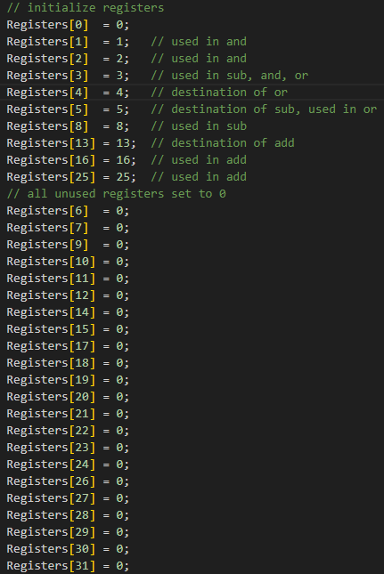
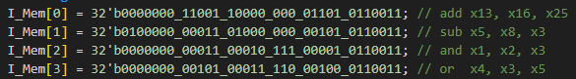
Expectation:
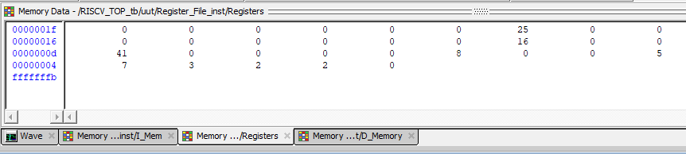
REG[13]=41;
REG[5]=5;
REG[1]=2;
REG[4]=7;

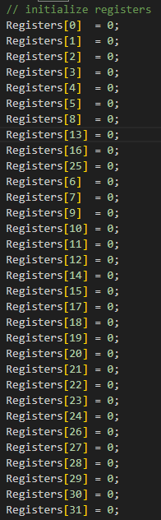

Expectation:
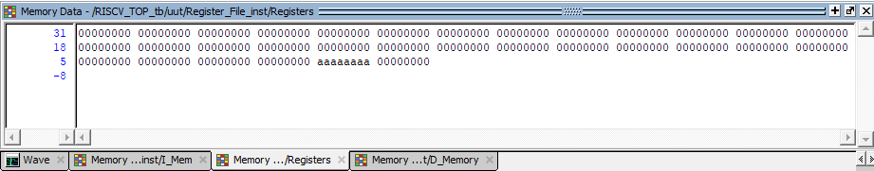
REG[1]=D_Memory[2];
REG[1]=32’hAAAAAAAA;
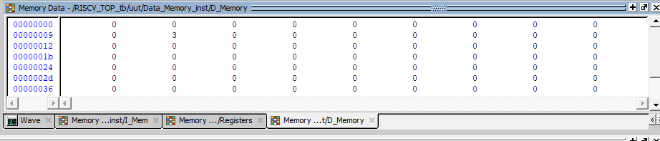
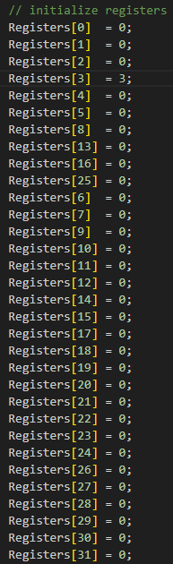
Expectation:
D_Memory[10] = REG[3]
D_Memory[10] = 3
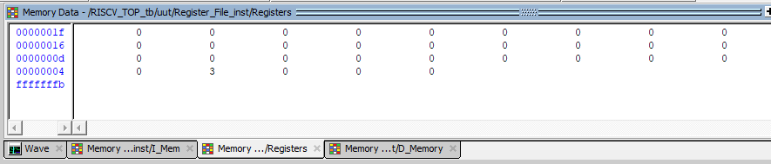
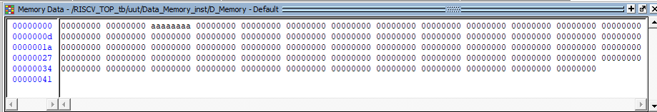

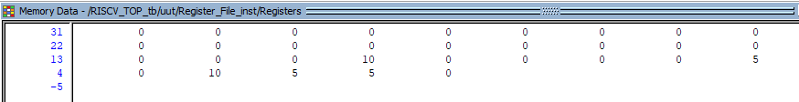
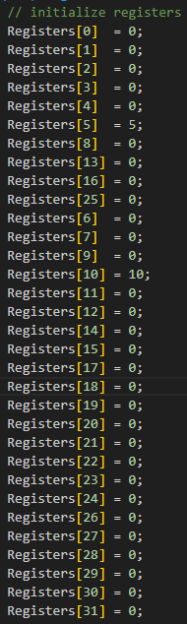
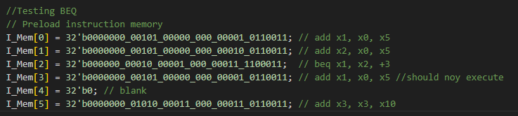
Expectation:
REG[1]=5;
REG[2]=5;
REG[3]=10;
If the BEQ didn’t occur I_Mem[3] would execute resulting in REG[1] being 10 by the end of the program.

